Big Data Hadoop and Spark Developer

Certification Project- Sheeba Varghese

**Stock Exchange Data Analysis**

DESCRIPTION

**Objective**: To use hive features for data engineering or analysis and sharing the actionable insights

**Problem Statement:**  
NewYork stock exchange data of seven years, between 2010 to 2016, is captured for 500+ listed companies. The data set comprises of intra-day prices and volume traded for each listed company. The data serves both for machine learning and exploratory analysis projects, to automate the trading process and to predict the next trading-day winners or losers.. The scope of this project is limited to exploratory data analysis.

**Domain**: BFSI

**Analysis to be done:** Exploratory analysis to understand how MoM or YoY companies from different sectors or industries and states have progressed in a period of 7 years

**Content:** This data set contains prices.csv and securities.csv files having the following features:

Prices.csv:

1. Date: Trading date
2. Symbol: Ticker code or listed company code on NY stock exchange
3. Open: Intra-day opening price for each listed company
4. Close: Intra-day closing price for each listed company
5. Low: Intra-day lowest price for each listed company
6. High: Intra-day highest price for each listed company
7. Volume: Number of shares traded per day per company

Securities.csv:

1. Ticker_Symbol: Country to which the customer belongs
2. Security: Legal name of the listed company
3. Sector: Business vertical of the listed company
4. Sub_Industry: Business domain of the listed company within a Sector.
5. Headquarter: Headquarters address

**Steps to perform:**

     1) Create a data pipeline using sqoop to pull the data from the table below from MYSQL server into Hive.

a. MYSQL DATABASE NAME: BDHS_PROJECT

i. Stock_prices  
ii. Stock_companies

Check the TABLE description: STOCK_PRICES

|  |  |
| --- | --- |
| Column Name | Datatype |
| Trading_date | Date |
| Symbol | String |
| Open | double |
| Close | double |
| Low | double |
| High | double |
| Volume | int |

TABLE: STOCK_COMPANIES

|  |  |
| --- | --- |
| Column Name | Datatype |
| Symbol | String |
| Company_name | String |
| Sector | String |
| Sub_industry | String |
| Headquarter | String |

Solution:-

Checking the mysql database, BDHS_PROJECT, to check the table schema and row count of tables,

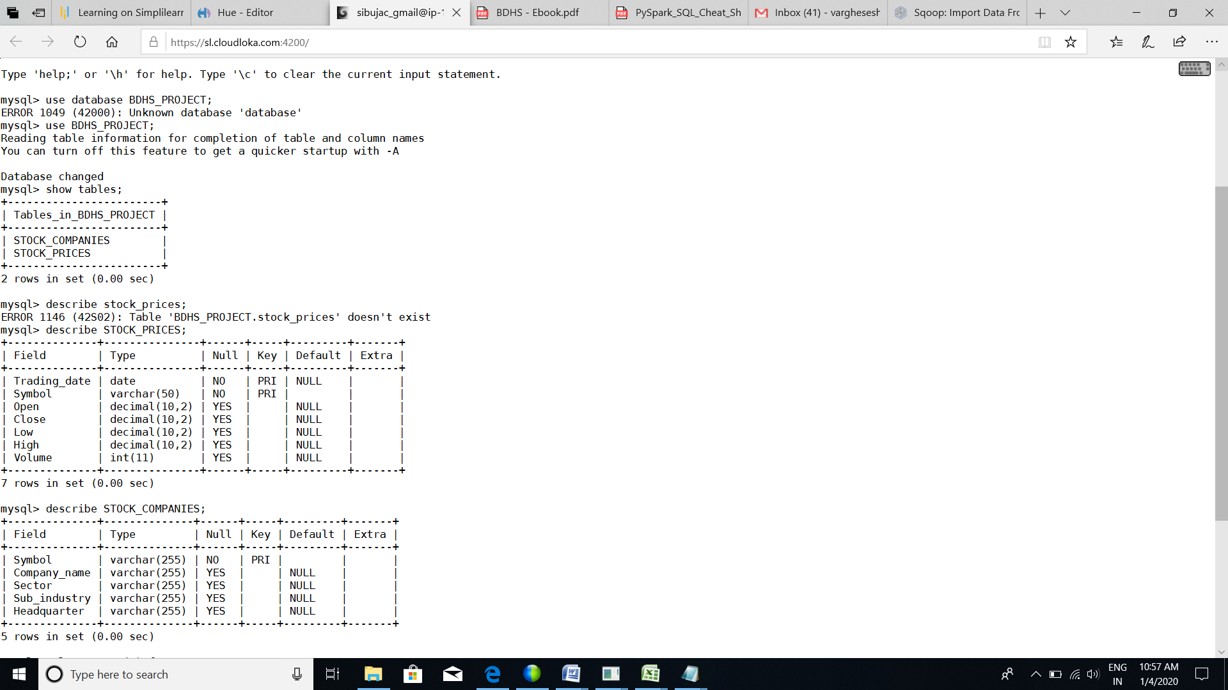

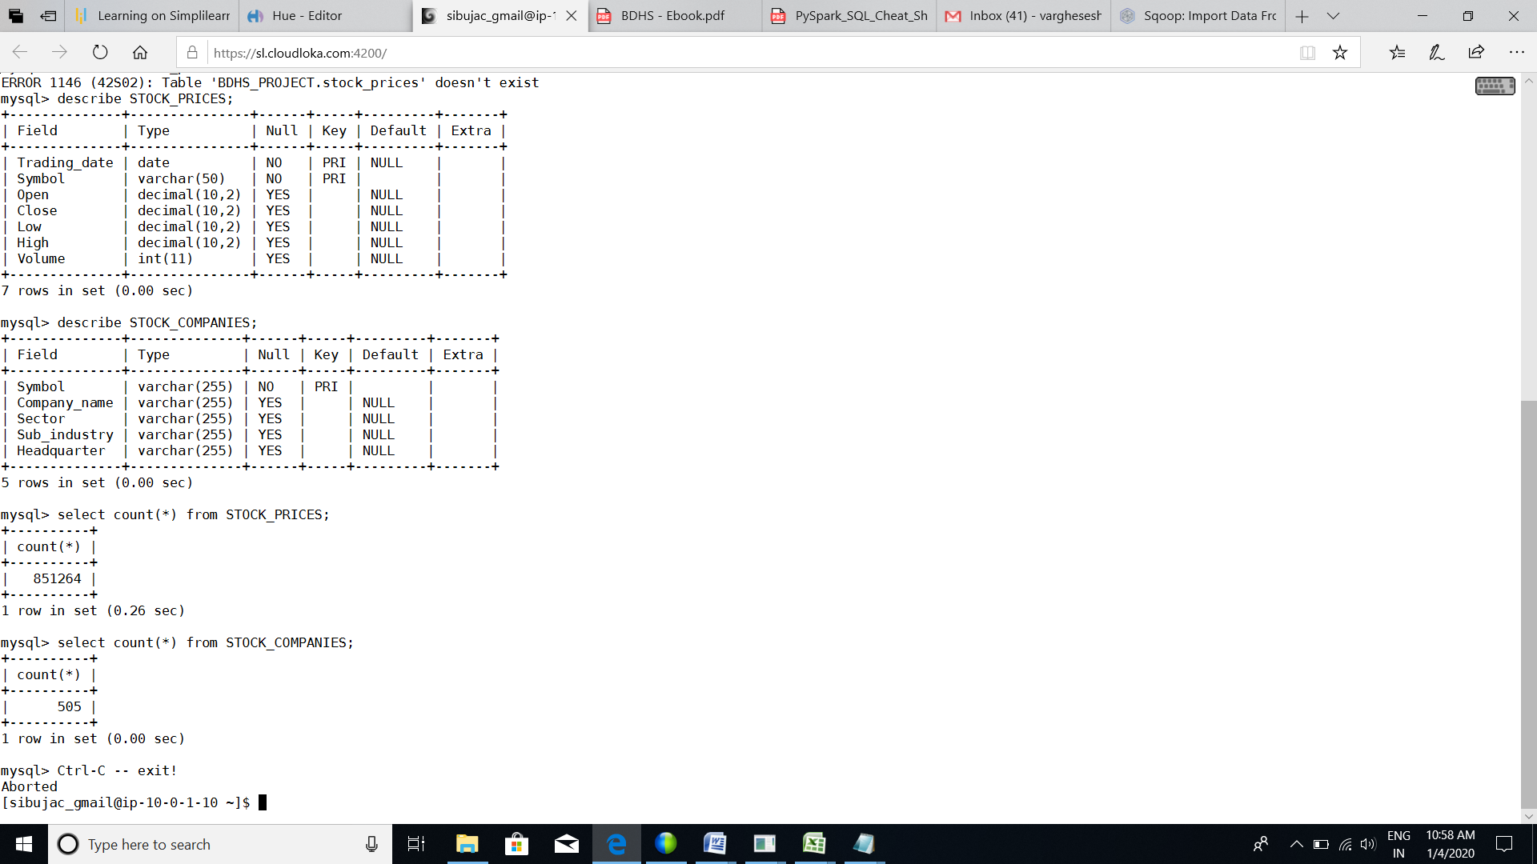

sqoop import --connect jdbc:mysql://ip-10-0-1-10.ec2.internal/BDHS_PROJECT --username labuser --password simplilearn --table STOCK_PRICES --hive-import --create-hive-table –hive-table sheeba_123.stock_prices --m 1

sqoop import --connect jdbc:mysql://ip-10-0-1-10.ec2.internal/BDHS_PROJECT --username labuser --password simplilearn --table STOCK_COMPANIES --hive-import --create-hive-table –hive-table sheeba_123.stock_companies --m 1

2) Create a new hive table with the following fields by joining the above two hive tables.  
Please use appropriate Hive built-in functions for columns (a,b,e and h to l).

* Trading_year: Should contain YYYY for each record
* Trading_month: Should contain MM or MMM for each record
* Symbol: Ticker code
* CompanyName: Legal name of the listed company
* State: State to be extracted from headquarters value.
* Sector: Business vertical of the listed company
* Sub_Industry: Business domain of the listed company within a sector
* Open: Average of intra-day opening price by month and year for each listed company
* Close: Average of intra-day closing price by month and year for each listed company
* Low: Average of intra-day lowest price by month and year for each listed company
* High: Average of intra-day highest price by month and year for each listed company
* Volume: Average of number of shares traded by month and year for each listed company

Solution:- ( Execute in hive)

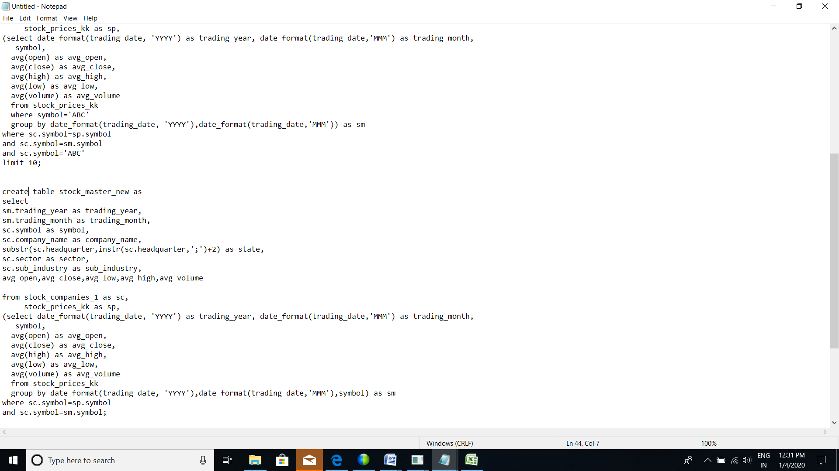

create table stock_master_new as

select sm.trading_year as trading_year, sm.trading_month as trading_month,

sc.symbol as symbol,sc.company_name as company_name,

substr(sc.headquarter,instr(sc.headquarter,';')+2) as state,

sc.sector as sector,sc.sub_industry as sub_industry,

avg_open,avg_close,avg_low,avg_high,avg_volume

from stock_companies_1 as sc, stock_prices_kk as sp,

(select date_format(trading_date, 'YYYY') as trading_year, date_format(trading_date,'MMM') as trading_month, symbol,avg(open) as avg_open,avg(close) as avg_close,avg(high) as avg_high,

avg(low) as avg_low,avg(volume) as avg_volume

from stock_prices_kk

group by date_format(trading_date, 'YYYY'),date_format(trading_date,'MMM'),symbol) as sm

where sc.symbol=sp.symbol and sc.symbol=sm.symbol;

**DATA ANALYSIS USING HIVE**

         3) Find the top five companies that are good for investment

Solution:-

Select company_name, avg(avg_high) as avg_symbol_high

from stock_master_new

group by company_name

order by avg_symbol_high desc

limit 5;

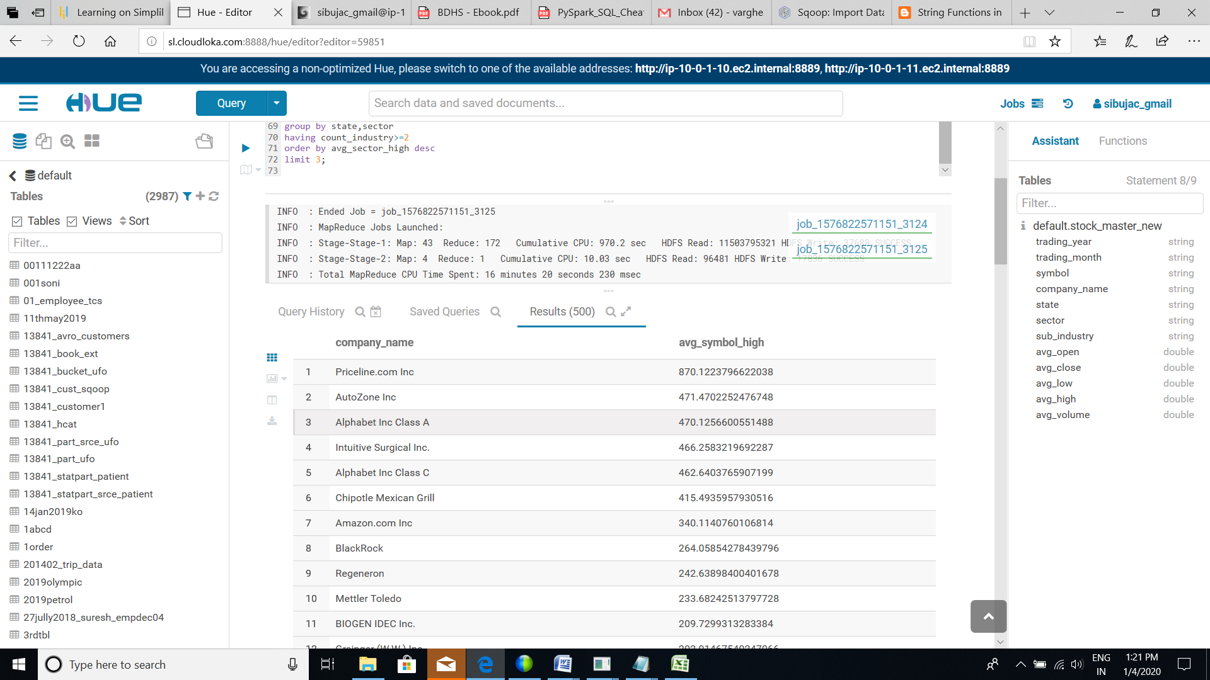

4) Show the best-growing industry by each state, having at least two or more industries mapped

Solution:-

Select state,sector,

avg(avg_high) avg_sector_high ,

count(sub_industry) count_industry

from stock_master_new

group by state,sector

having count_industry>=2

order by avg_sector_high desc;

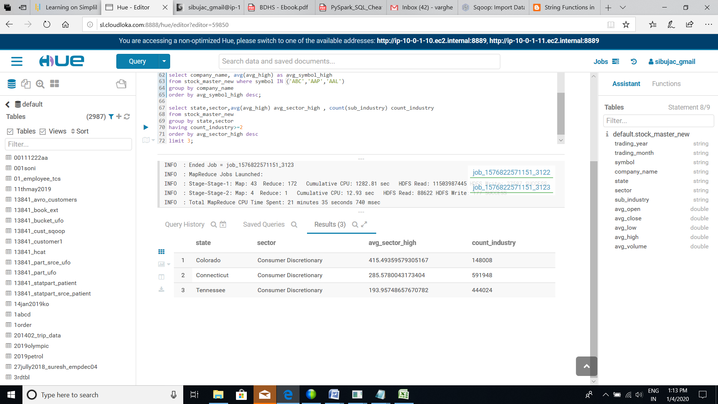

5) For each sector find the following.

* Worst year

Solution:-

select sector, trading_year worst_year

from

(select sector, trading_year,avg_sector_volume_per_year,

rank() over(partition by sector order by avg_sector_volume_per_year) as rn

from

(select sector, trading_year, avg(avg_volume) avg_sector_volume_per_year

from stock_master_new

group by sector,trading_year ) a) b

where b.rn=1;

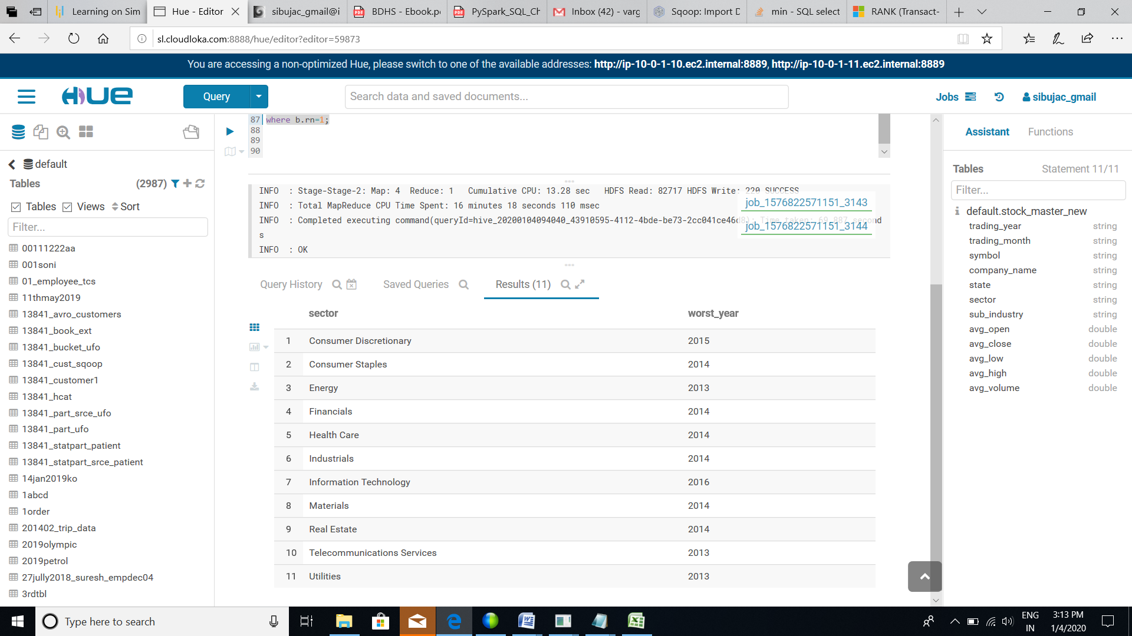

* Best year

Solution:-

select sector, trading_year best_year

from

(select sector, trading_year,avg_sector_volume_per_year,

rank() over(partition by sector order by avg_sector_volume_per_year desc) as rn

from

(select sector, trading_year, avg(avg_volume) avg_sector_volume_per_year

from stock_master_new

group by sector,trading_year ) a) b

where b.rn=1;

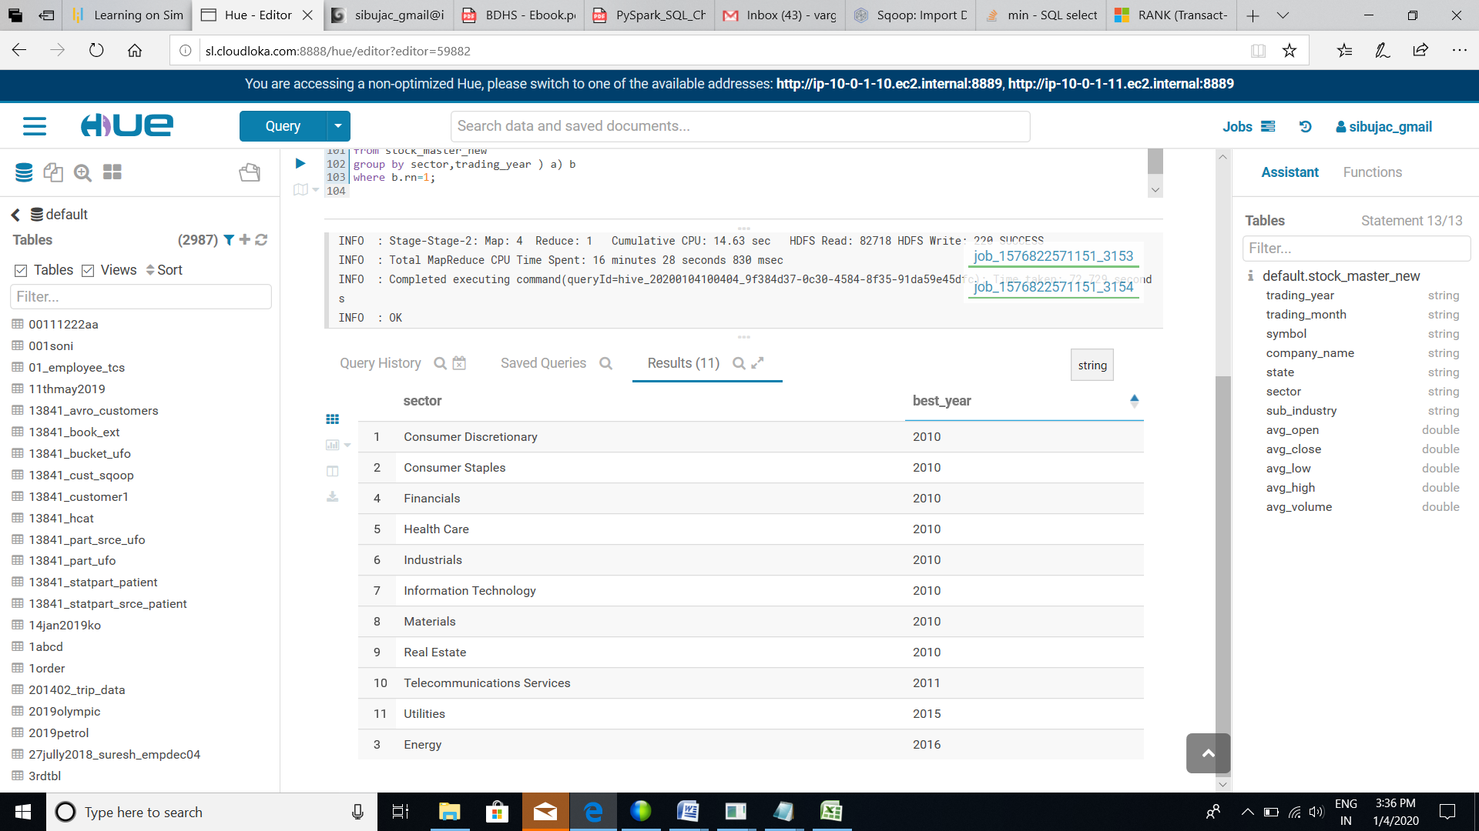

* Stable year

Solution:-

Select sector, trading_year stable_year

from

(select sector, trading_year,avg_sector_stability,

rank() over(partition by sector order by avg_sector_stability) as rn

from

(select sector, trading_year, avg(avg_high-avg_low) avg_sector_stability

from stock_master_new

group by sector,trading_year ) a) b

where b.rn=1;

